2023-24 Volunteer Grants Opportunity

Expression of Interest

Complete and return this form to your Member of Parliament to express your organisation’s interest in the 2023-24 Volunteer Grants Opportunity administered by the Department of Social Services. Please refer to the Grant Opportunity Guidelines for more information on eligibility requirements.

Organisation Details

Organisation Name:

Organisation ABN:

Organisation Address:

 | Town/Suburb |  | State |  | Postcode

Activity Address*:

State

Postcode

*The activity address refers to the address where the volunteering activity occurs. If this is the same as the organisation address, this field can be left blank.

Primary Contact Name: |  | Mobile:
Email:
Secondary Contact Name: |  | Mobile:
Email:

Questions
All funding sought must directly benefit your organisation’s volunteers.
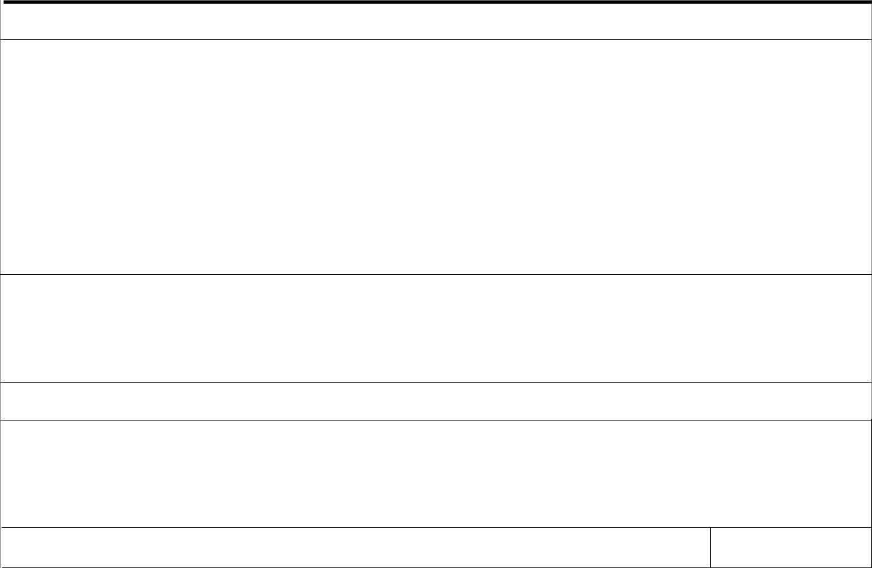

1. What does your organisation do to support the local community?

2. | Do volunteers make up 40% or more of your organisation’s staff? | Yes | No
3. | What is the total amount of funding being sought? (between $1000 and $5000) | $

- What is the funding being sought for? (please refer to Section 5 and Appendix A of the guidelines for eligible items/activities)

- How will the project directly benefit your organisation’s volunteers?

6. Has anyone from your organisation submitted an expression of interest in another electorate ?

Yes No

SIGN OVER PAGE ₁

Further Information

All applications will be assessed by an independent panel. Grants are not ongoing and recommendations from the panel will be assessed by the Department of Social Services. Please attach any supporting documentation i.e. letters of support. Please be aware that if your organisation is nominated to apply for a Volunteer Grant, some or all of this information will be shared with the Department of Social Services.

Note: If your organisation is an unincorporated association, a person connected to your organisation will be required to assume personal legal liability. The person will be legally liable for the delivery of the funded activity, expenditure of funds and any other associated obligations arising from the grant agreement. For more information see Section 4 of the Grant Opportunity Guidelines.

I, declare that the details provided above, to the best of my knowledge, are true and correct (Print name)

(Authorised Representative Signature Required)

Please return the completed form to your Member of Parliament

2

